**EXPERIMENT 3**

**Aim :**

To prepare ER Diagram for the Application Software – **Bill Management System.**

**Theory :**

**What is ER Model ?**

The Entity Relationship Model is a high-level conceptual data model diagram. ER Model is based on the notion of real-world entities and the relationship between them. ER modelling helps you to analyse data requirements systematically to produce a well-designed database. So, it is considered a best practice to complete ER modelling before implementing your database.

**What is ER Diagram ?**

Entity Relationship Diagram displays the relationships of entity set stored in a database. In other words, we can say that ER Diagrams help you to explain the logical structure of databases. At first look, an ER Diagram looks very similar to the flowchart. However, ER Diagram includes many specialized symbols, and its meanings make this model unique.

**Why use ER Diagram ?**

* Helps you to define terms related to entity relationship modelling.
* Provides a preview of how all your tables should connect, what fields are going to be on each table.
* Helps to describe entities, attributes, relationships.
* ER Diagrams are translatable into relational tables which allows you to build databases quickly.
* ER Diagrams can be used by database designers as a blueprint for implementing data in specific software applications.
* The database designer gains a better understanding of the information to be contained in the database with the help of ER Diagram.
* ER Diagram allows you to communicate with the logical structure of the database.

**What are the Components of ER Diagram ?**

* **Entity :** A real-world thing either living or non-living that is easily recognizable and non-recognizable. It is anything in the enterprise that is to be represented in our database. It may be a physical thing or simply a fact about the enterprise or an event that happens in the real world.
* **Relationship :** Relationship is nothing but an association among two or more entities. For example – Tom works in the Chemistry department. Entities take part in relationships. We can often identify relationships with verbs or verb phrases.
* **Attribute :** It is a single-valued property of either an entity-type or a relationship-type. For example, a lecture might have attributes : time, date, duration, place, etc. An attribute is represented by an Ellipse.

ER Diagram for the Application Software – **Bill Management System :**

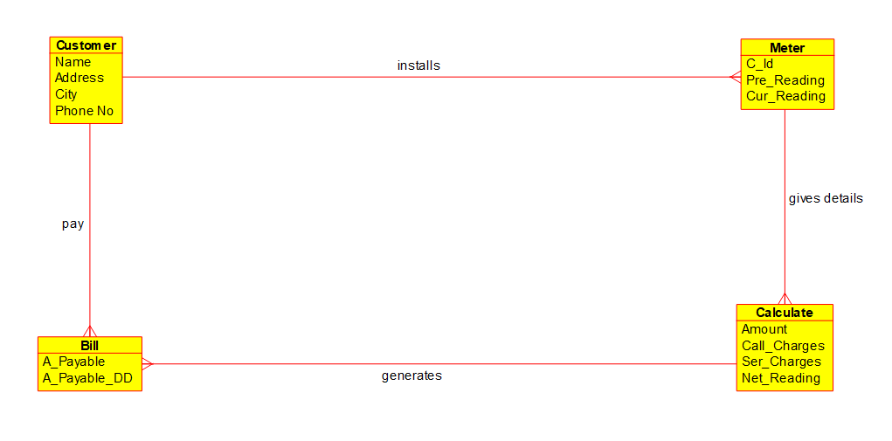

**Conclusion :**

The ER Diagram for the Application Software – **Bill Management System** was prepared successfully.